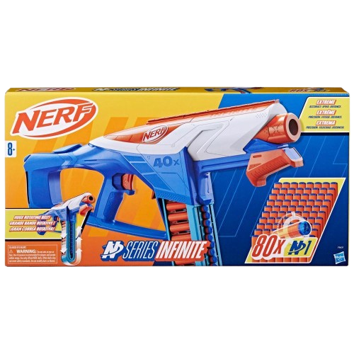****

**Nerf Infinite**

**Price: $19.99**

**Provides a thrilling experience with its endless dart capacity and superior firepower**

**Continuous rapid-fire action for intense Nerf battles**

**The Nerf N-Strike Elite Infinite is a high-performance blaster designed for endless, rapid-fire action. Featuring an advanced, motorized design, this blaster allows you to shoot continuously without the need for manual reloading an a good range**

**.**

.

**Product details**

**THANK YOU!**

**WELLCOME TO OUR WEBSITE**